**PYTHON**

**LOOPS**

S.R.TAANUSRI

13.12.2023

1.IF STATEMENT

* Make decisions in code based on certain conditions.
* It allows program to execute different blocks of code.
* Depending on whether a specified condition evaluates to true or false.

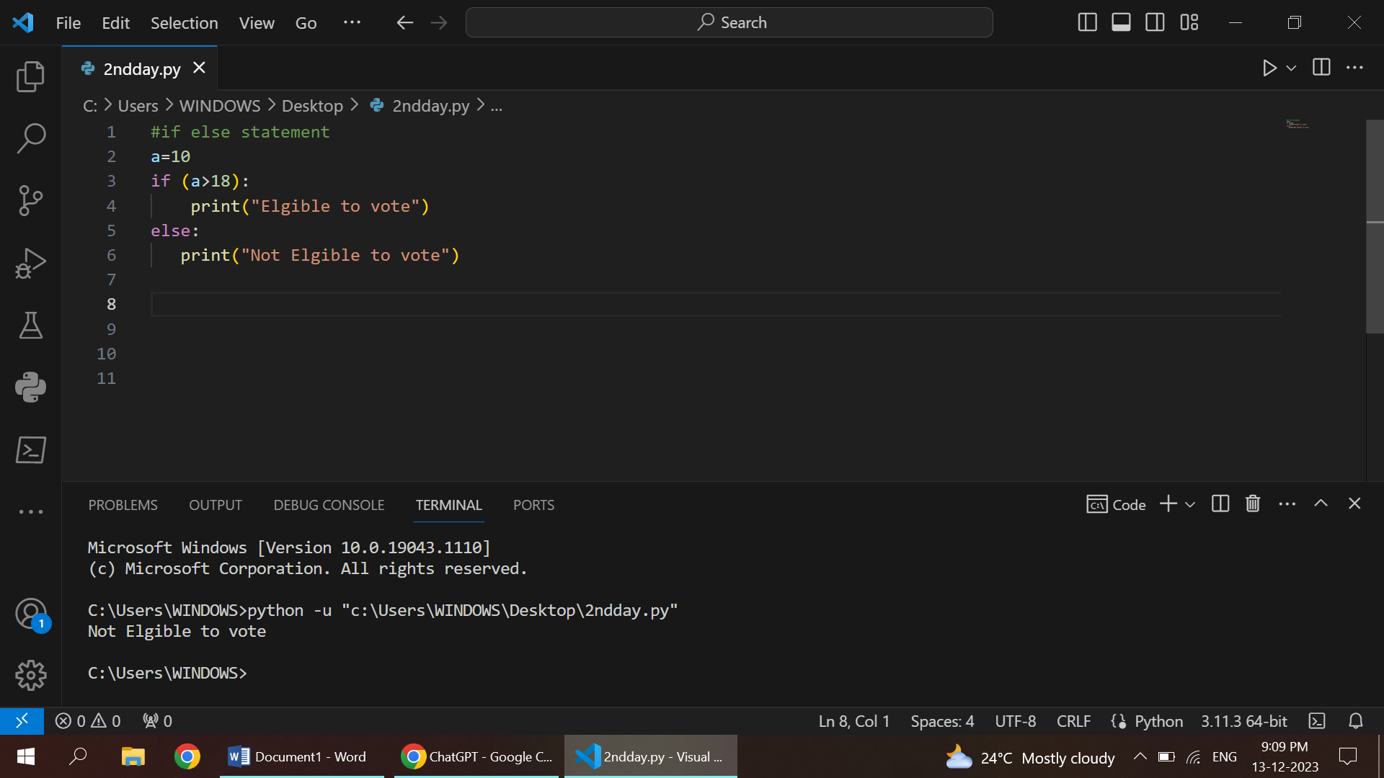

2.ELSE STATEMENT

* The else block is not mandatory.
* If it is omitted, and the condition is false, the program simply continues with the next set of instructions after the if statement
* The else statement is used to handle alternative scenarios or conditions.
* It provides a way to define a default or fallback behavior when the specified condition is not met.

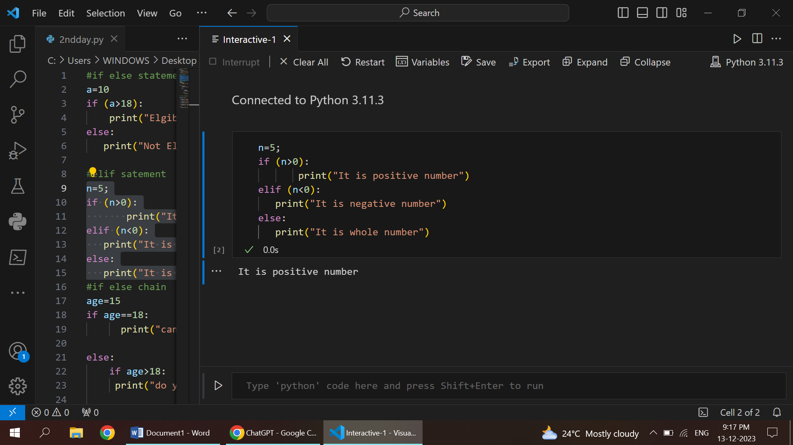

3.IF CHAIN STATEMENT

* This statement is a series of conditional statements in programming that allows you to check multiple conditions sequentially.
* This construct provides a way to handle different scenarios or branches of logic based on the evaluation of these conditions.

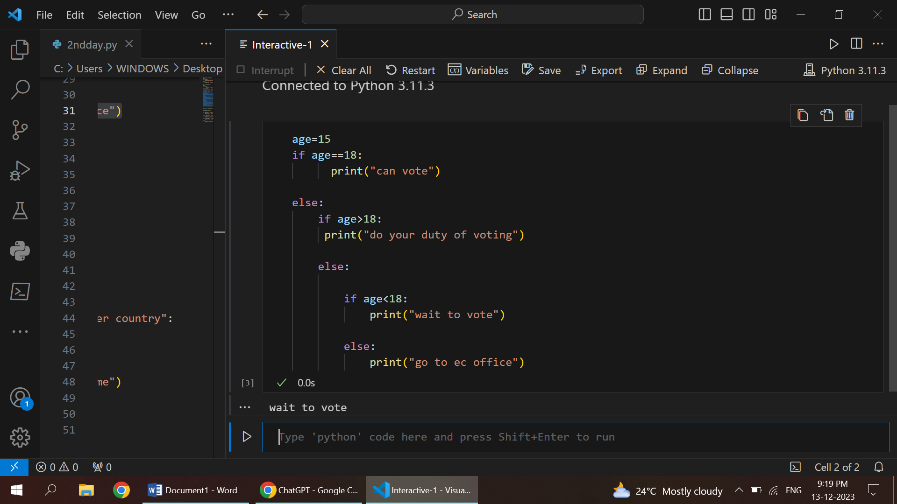

4.IF ELIF STATEMENT

* A programming construct that allows for the evaluation of multiple conditions in a sequential manner.
* It provides a way to handle various scenarios by checking each condition one by one until a true condition is encountered or until all conditions are checked.

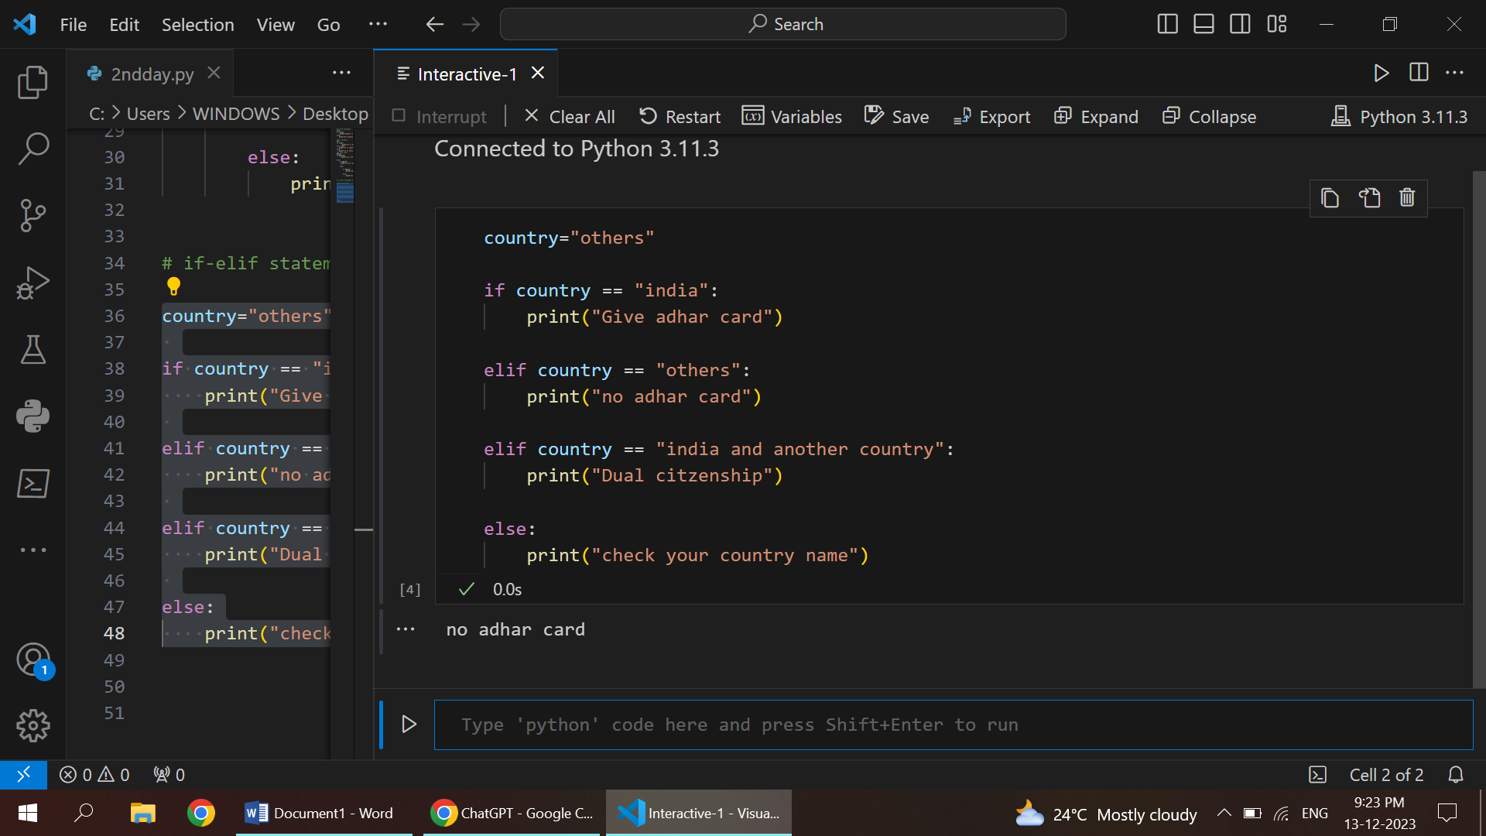

5.WHILE CONDITION

* An expression that is evaluated before each iteration of the loop.
* If the condition is true, the code inside the loop is executed. I
* f the condition is false, the loop is exited, and the program continues with the next statement after the loop.

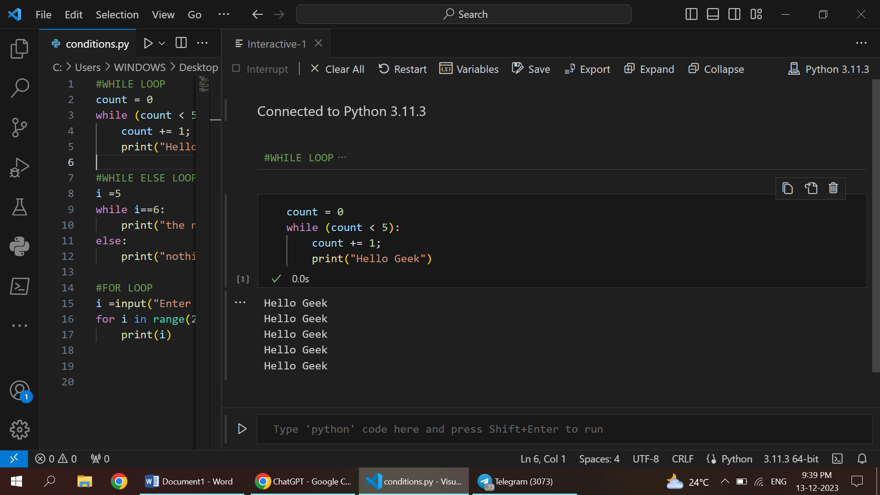

6.WHILE ELSE CONDITION

* An expression that is evaluated before each iteration of the loop.
* If the condition is true, the code inside the loop is executed.
* If it becomes false, the loop exits, and the else block is executed.

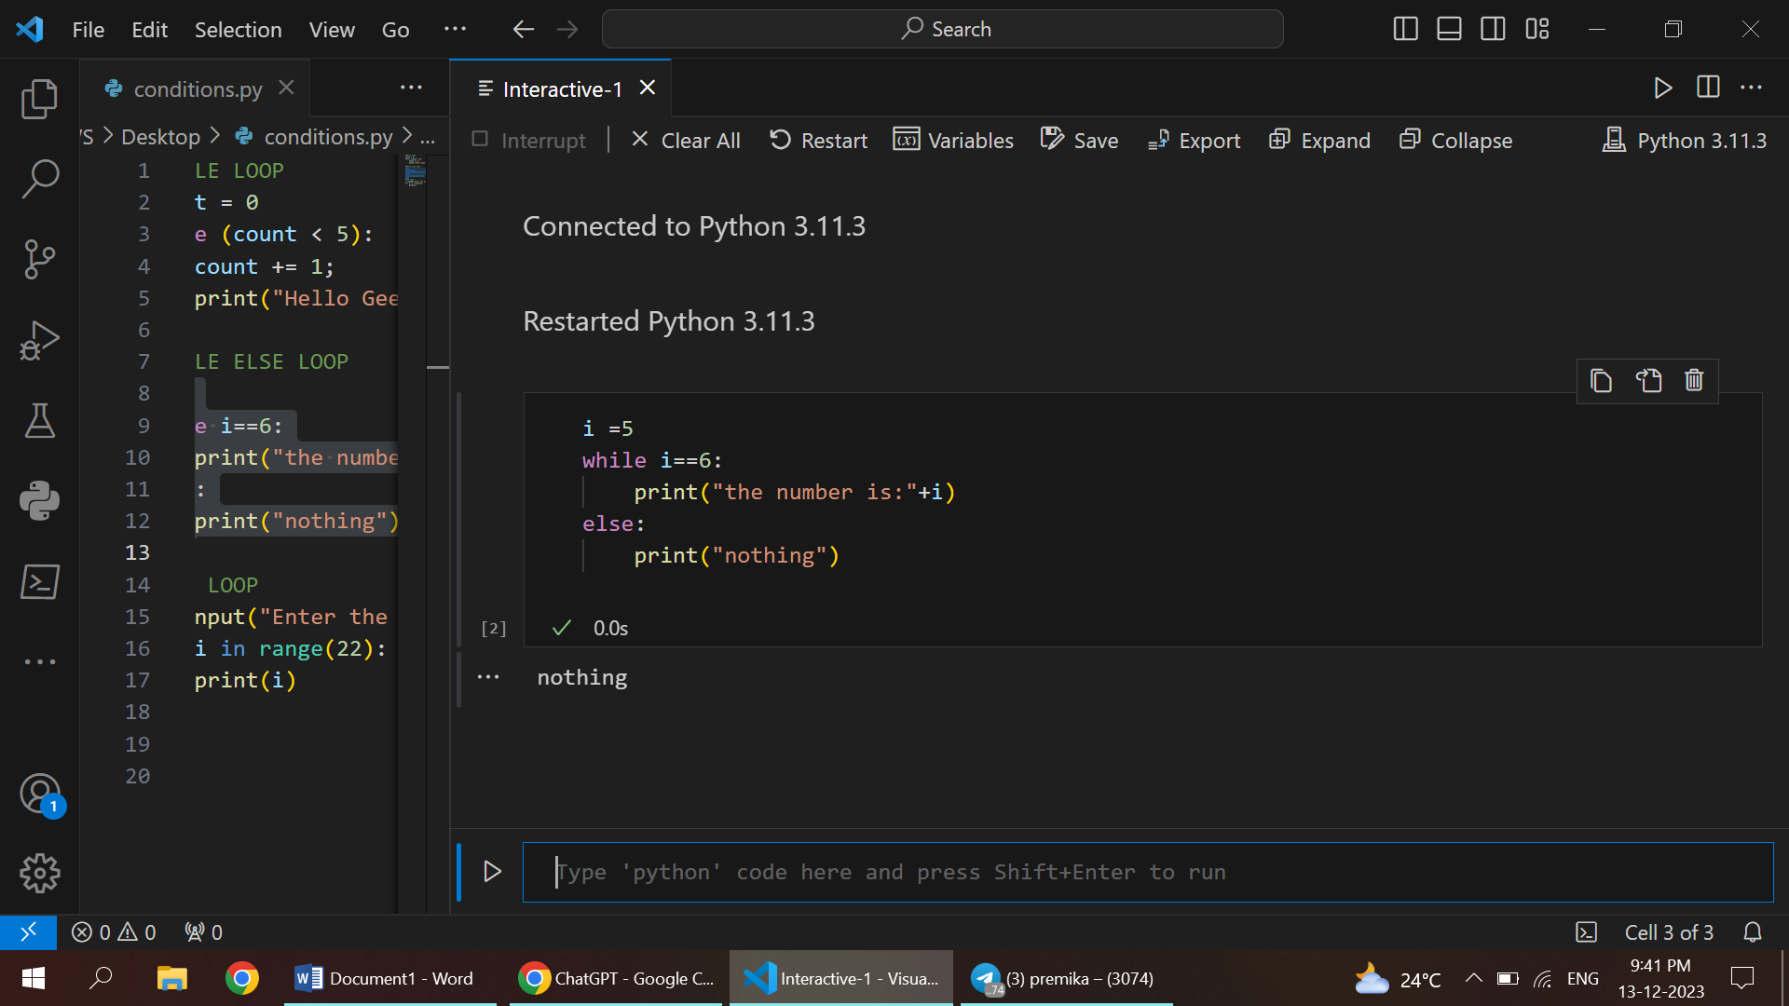

7.FOR LOOP

* Represents the current item in the sequence during each iteration of the loop.
* The variable takes on the value of each item in the sequence in turn.
* Specifies the iterable object over which the loop will iterate.

